*Figure 1.* Schematic timeline of experimental procedure.

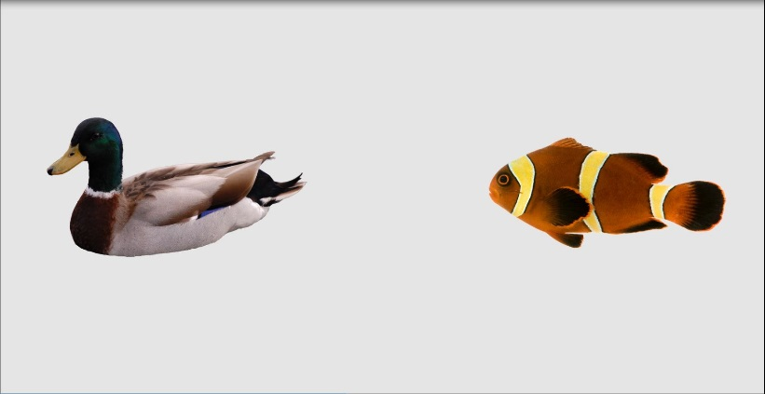

Fish

Look! Can you find the good

3000 ms

Target

Onset

Trial Start

Picture Onset

Auditory Stimuli Onset

7000 ms

End of trial

Picture Disappears

0 ms